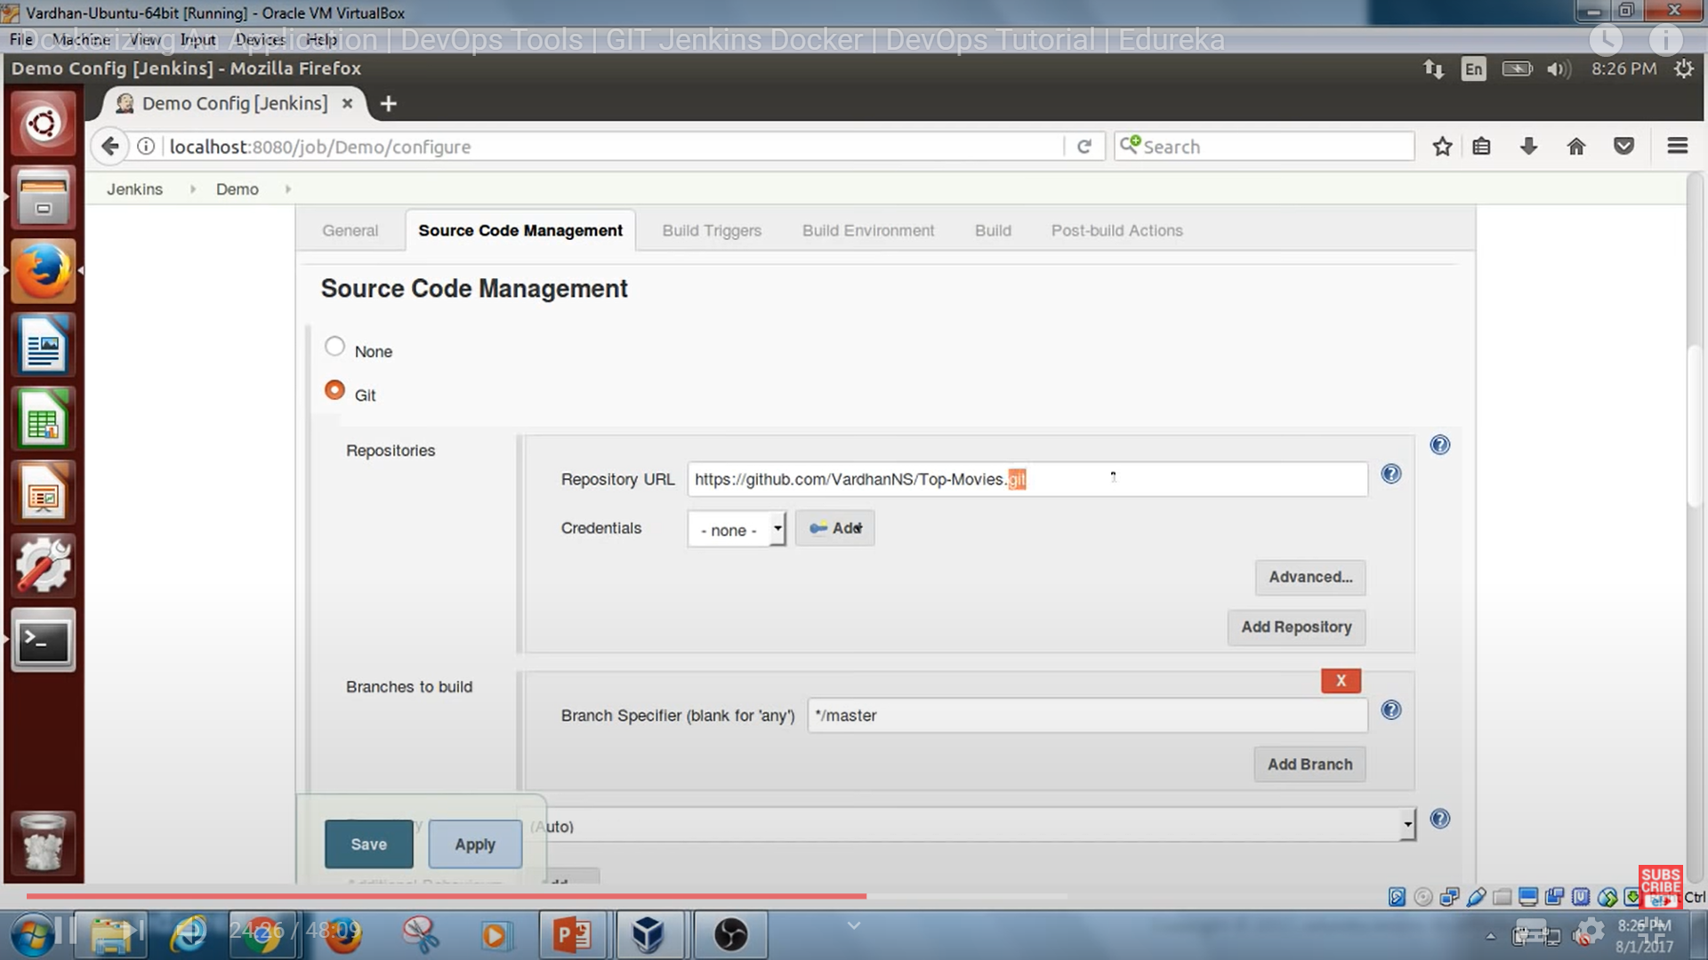we need to give sudo access to Jenkins user or add Jenkins user to docker group.

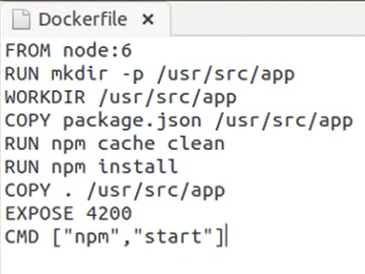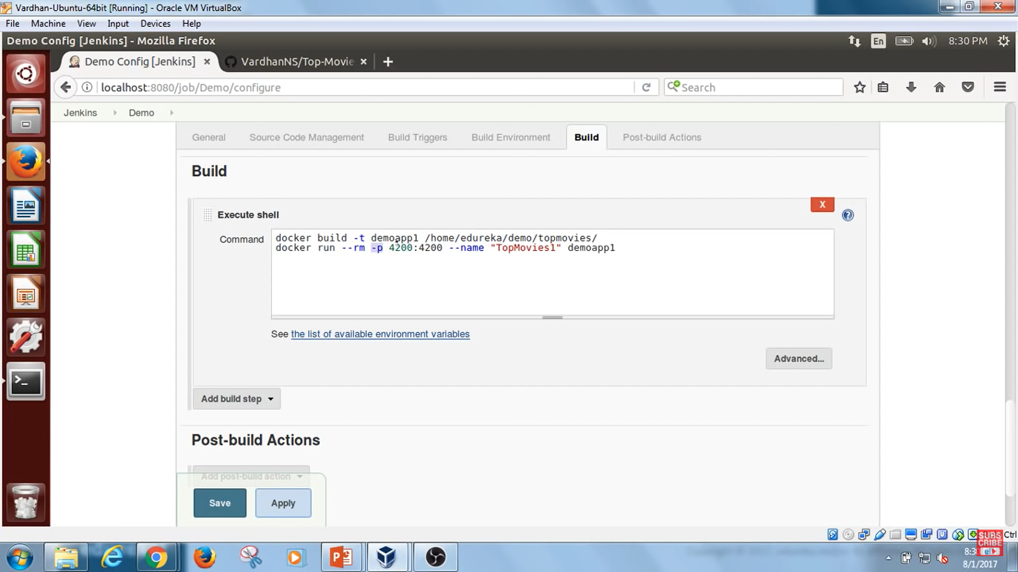

Building an image of name demoapp1 based on docker file which is present at (/home/edureka/demo/topmovies/ )

mentions location of my docker host machine.

Then run image(demoapp1) to create container of name topmovies1, expose port 4200(host machine port):4200(container port).

ANOTHER EXAMPLE

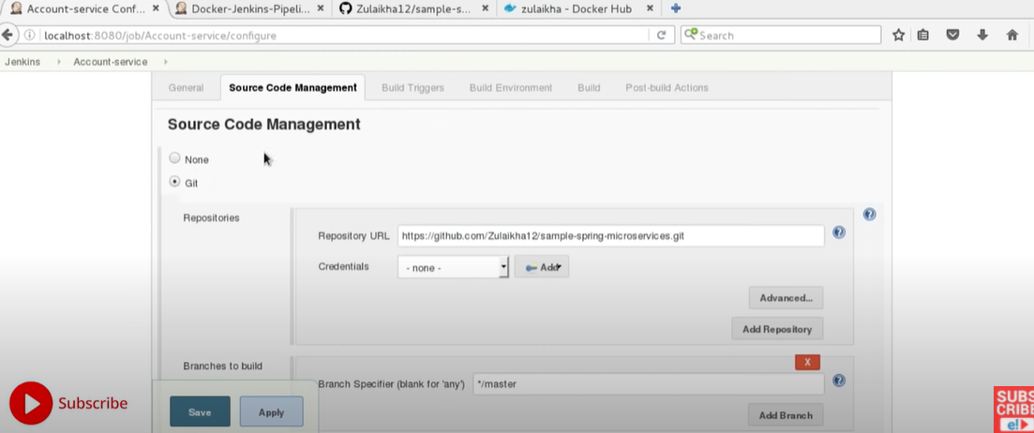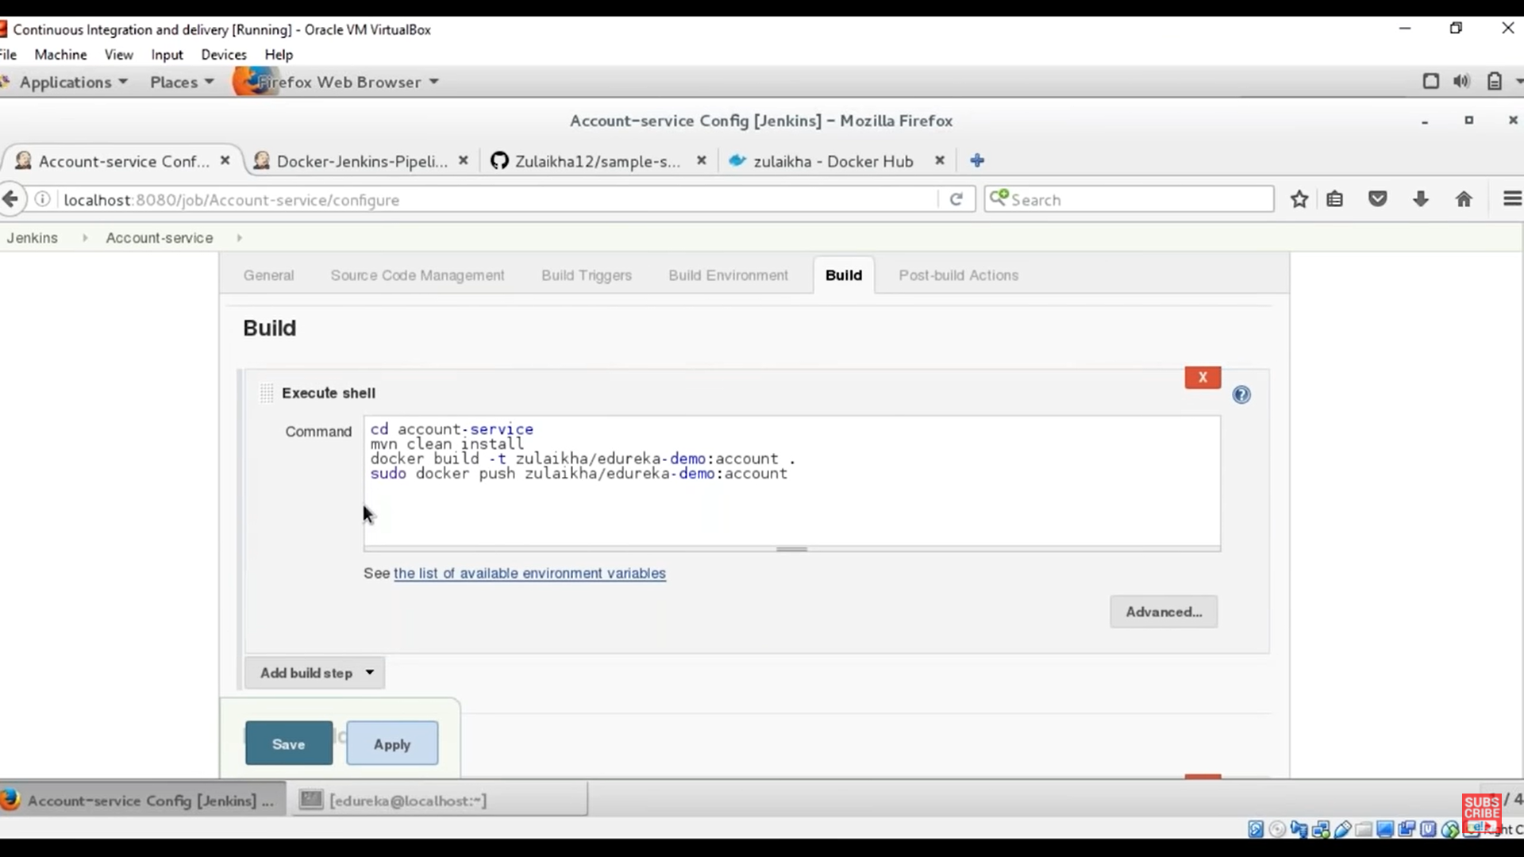HERE WE CREATE DOCKER IMAGE IN DOCKER HUB ACCOUNT.AND PUSH IT TO DOCKER HUB ACCOUNT

NOTE BATTER TO TAG IMAGE NAME LIKE prashantkatare/demoapp1

Above prashantkatare is my user name of dockerHub account/imagename.

#cd account-service (project folder) where image need to be build

#docker build -t prashantkatare/demoaccount .

#docker push prashantkatare/demoaccount

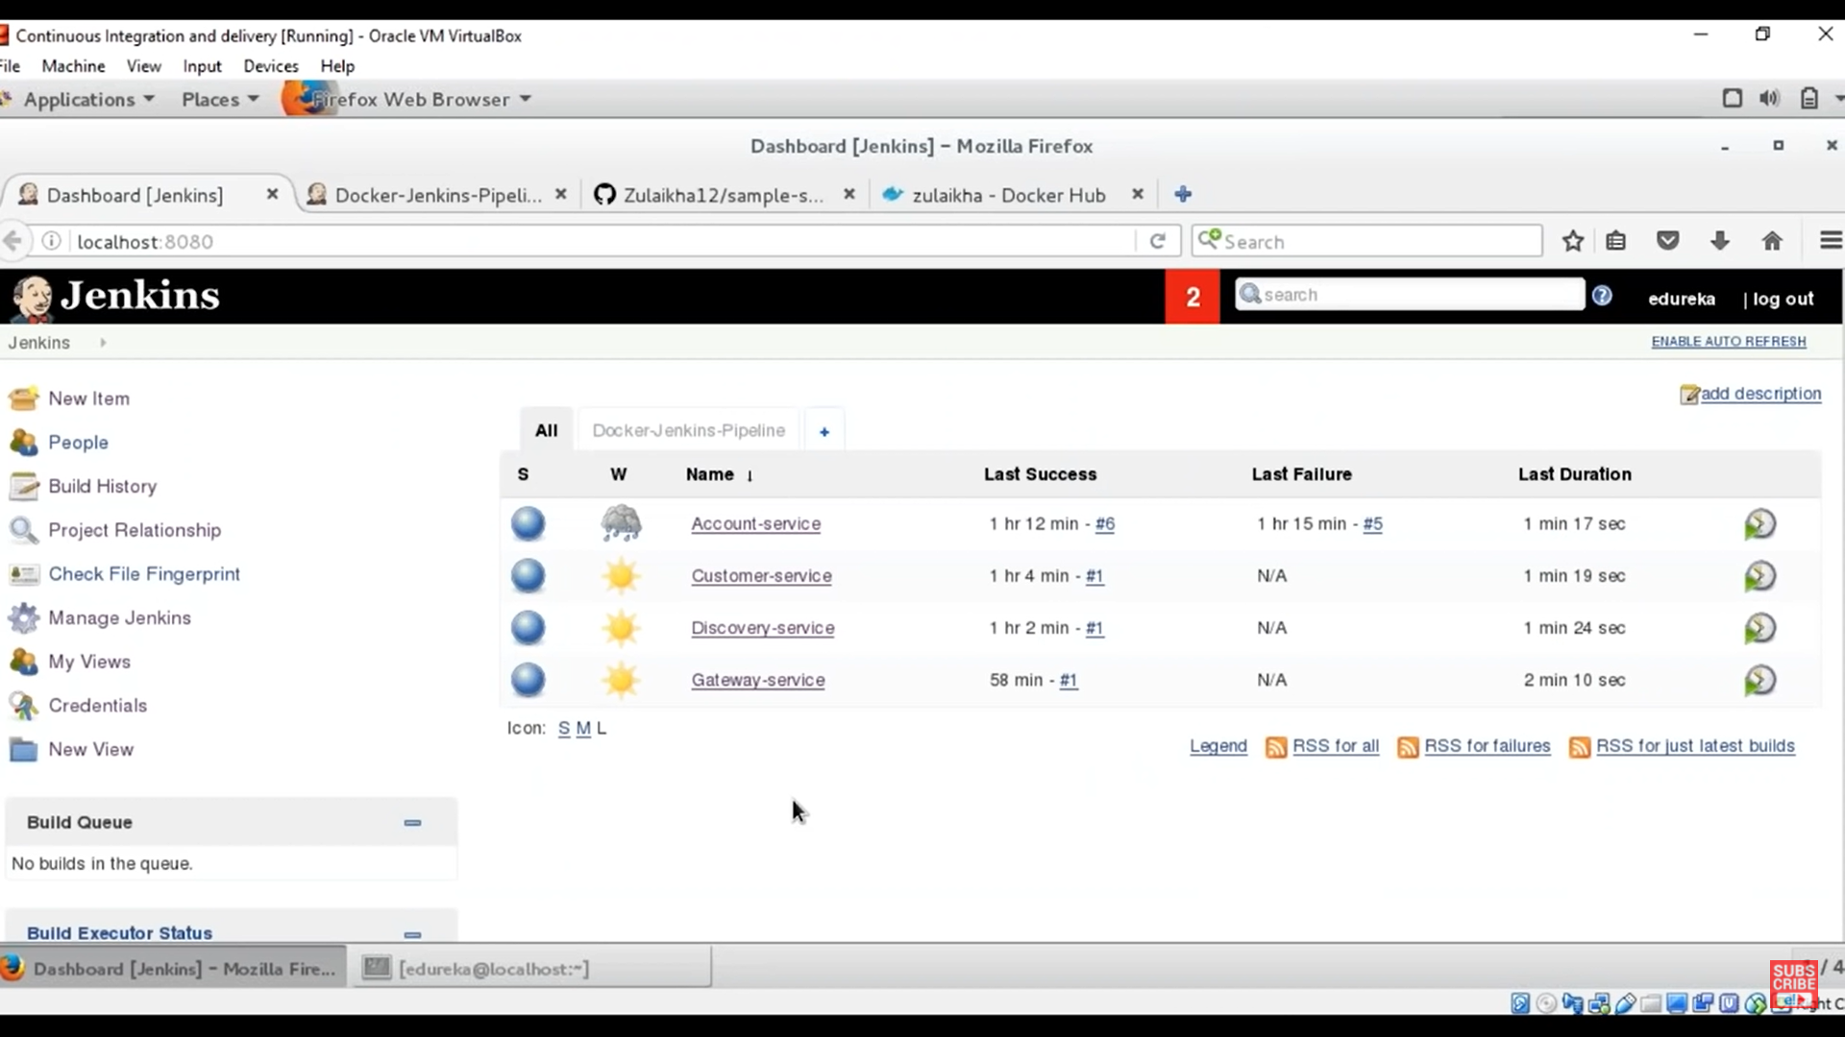 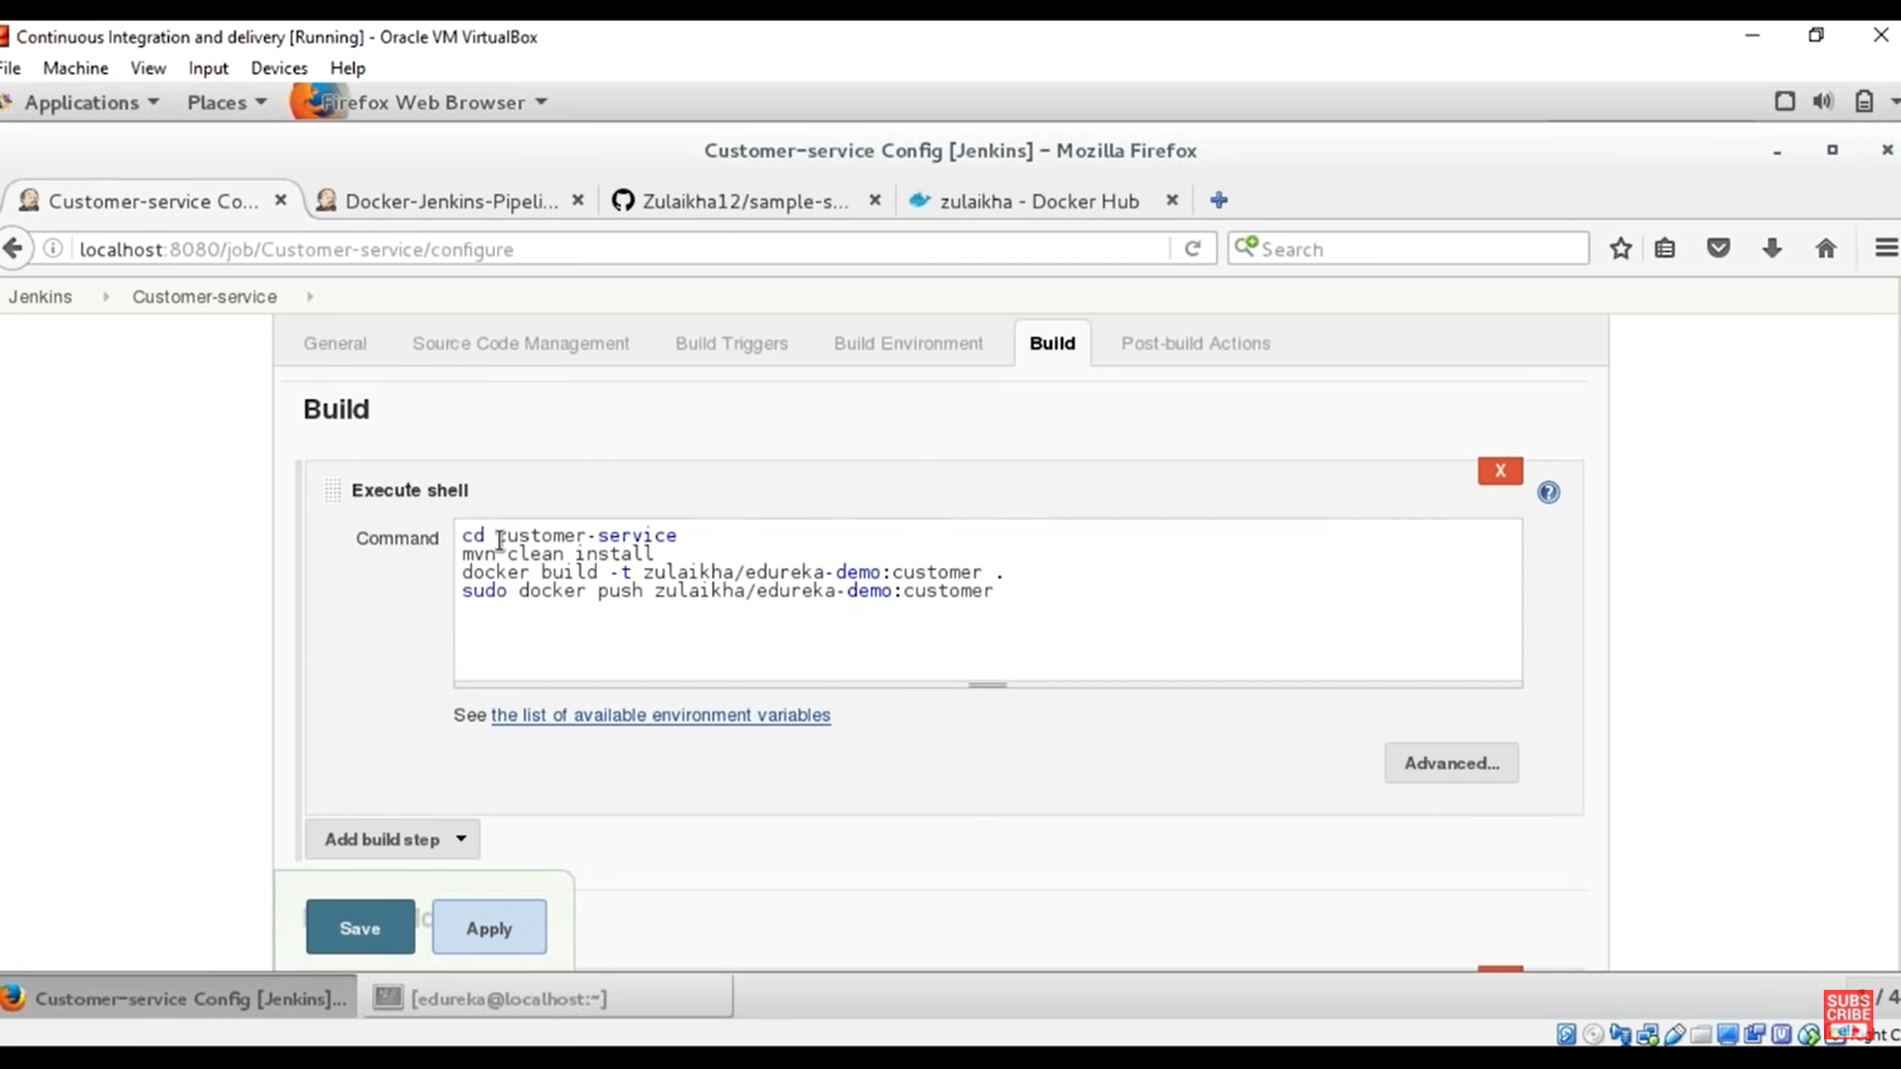

#cd customer-service (project folder) where image need to be build

#docker build -t prashantkatare/democustomer .

#docker push prashantkatare/democustomer

TO RUN ALL JUBS PARALLEL WE NEED TO CREATE A BUILD PIPELINE ON JENKINS.